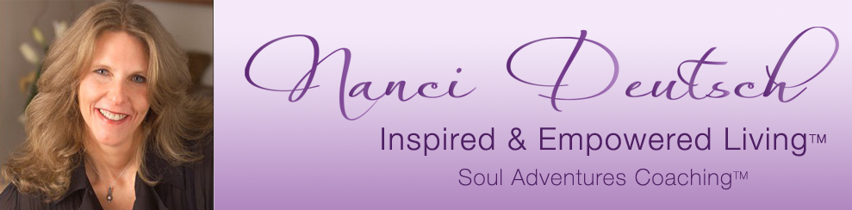

Worksheet for Uncovering Your Belief

1. The block I need to clear most today regarding ____________ is……….

______________________________

______________________________

______________________________

_______________________________

_______________________________

2. The purpose of this (unwanted experience, issue)_____________ is…………

_____________________________

______________________________

_____________________________

____________________________

_____________________________

3. In order to have ………., I need to change…………..

_____________________________________

___________________________________

______________________________________

_____________________________________

______________________________________

4. So the belief I need to change most regarding _______________
is ………..

____________________________________________

____________________________________________

___________________________________________

_____________________________________________

_____________________________________________

Copyright 2015

